Urbanization and Social Sustainability:
Policies and Strategies for Achieving Well-being
Felia Srinaga¹; Finarya Legoh²
¹Associate Professor and Head of Research & Community Services, Department of Architecture, School of Design, University of Pelita Harapan, Indonesia
Email: felia.srinaga@uph.edu
² Director for International Relation of the Indonesian Academy of Sciences /
Senior Lecturer at the School of Design, University of Pelita Harapan
Email: finaryalegoh@gmail.com

Abstract
Urbanization is caused by various factor, both pull and push factors from cities and rural areas. The urbanization in Indonesia increases due to lack of infrastructure and facilities in rural areas and demand pull from trade and industrial sector in urban area. The momentum of large urbanization to big cities is triggered during and after Eid Al-Fitr, when the relatively low level education workers seek a better challenge in the informal sectors such as selling street vendors, opening stalls, hawker and the like.
Large concentration area of population as a result of urbanization has an impact on environmental, social, cultural, economic and political problems. Then, In Indonesia, there is an opportunity to provide special characteristic or identity for cities with unique community life and the work that they develop. This paper aims to look at socio-cultural and psychological problems which challenge the realization of well-being in cities and rural areas. The methodology used is from both literature and review of precedents.
Urbanization should be well controlled in order to bring many benefits to the development of the city, especially for its economic development. However, the socio-cultural and psychological problems that characterize the life of migrants need special attention, as well as for urban governance. This paper then recommends policies and coping strategies in the physical and economic fields, in order to achieve well-being and to improve quality of life through social sustainability studies.
Key word: Urbanization, Social sustainability, Well-being

Background
Urbanization refers to the movement of population from rural to urban areas. It is a pattern that cannot be avoided in a country, especially for the Lower and Middle Income Countries (LMIC). It generally creates worldwide problems, regarding the number of features posed in the urban areas. Many large cities in developing countries, including in Indonesia, have experienced rapid urbanization. According to the World Bank key findings, the annual rate of urbanization growth in Indonesia reaches 4.2%. Jakarta, which is the capital city of the country, is a city that has the largest urbanization rate in Indonesia. By 2025 Indonesia may have 68% of its population living in cities (UN-Habitat, undated).
The urbanization in Indonesia, especially in Jakarta, has occurred due to the attractiveness of Jakarta as the capital city with all facilities as a metropolitan city, as well as the driving factor from the rural areas. Inequality in the development of infrastructure and facilities has encouraged villagers to attempt their luck in big cities in improving their economy. As for other cities in Indonesia, the demand pulled in the cities from industrial and trade sectors which are the valence for people to move to big cities.

The uneven distribution of population between cities and villages creates various gaps. It is quite alarming and becomes one of the serious social problems in Indonesia. On one hand, urbanization with a large population concentration area in a city will eventually have an impact on the problems. The aspects related to the adequacy of public service with numerous populations, settlements related to their space and environment, work force, and well-being in urban areas. On the other hand, the less population especially younger generation in the rural areas also affects to the economic, social and cultural problems (World Health Organization, 2007).
The momentum that has triggered large migration to big cities in Indonesia is especially during the Eid-ul-Fitr holiday. The intention to come and settle in the city is generally due to the invitation of friends / family who have come to the city first, to seek better opportunities. This urbanization faces other challenges since those workers have relatively low levels of education and they commonly work in the informal sector, such as street vendor sellers or stalls, hawkers / peddlers and the like. The Hope of changing better destiny sometimes turns out to be a disappointment with its inability to coping with harsh urban life. So that this urbanization may create negative impacts, such as the occurrence of slums and unhealthy settlements in urban villages, as well as crime and violence. Thus, urbanization in Indonesia faces some serious challenges, such as socio-economic inequities, unhealthy slums and housing, environmental and ecological degradation, etc. Besides problems and challenges faced by urbanization, in fact urbanization can have a positive impact if it is well managed and controlled. So that there is an opportunity for the city growth, especially for the economic development, as well as the economic status of the people that is displaced from the lower class to the middle class.
The positive impact of urbanization in improving the economy life of its people, also has the potential in creating a unique urban development identity. It has the opportunity to provide special trait or identity to the city occupied with life and work with the unique friendship community that they have developed. It is formed in the indigenous and migrant communities. Residence that joins with small business place is one of the special characteristics of dense settlements in Jakarta as well as other big cities.
The policy for urban growth needs to consider the negative and positive impacts of urbanization. Possible policies, actions and intervention, between central and local government in facing challenges and opportunities caused by urbanization have to be contemplated. The city development is not merely for the economic needs, but it also pays attention to the specificity of socio-cultural life of the individual and community formed. In some places, the occurrence happens in social segregation between residents and migrants, life style that only focuses on their own community, economic inequality and cultural diversity of migrants (which should be a developed uniqueness). The emerging of industrial and trade sectors in the cities leads to different life style of residents and migrants as before. As a result, the physical and economic development of the city is not merged with social and cultural development. For this reason, this paper discusses the issues and challenges of urbanization in Indonesia especially in Jakarta. Strategies and solutions of urban growth design are put forward in creating sustainability in social development and providing social well-being for large space of urban community in the form of public spaces (World Health Organization, 2016, Lennard, 2012).

Problems and Challenges of Urbanization in Indonesia
The migrants are generally friends or relatives of previous urban residents who have came and occupied the city in a longer period. The new arrivals commonly seek the settlement close to the previous residents. The density of urban villages in Jakarta continues to increase particularly, while the capacity of urban land space does not increase. Settlements created by urban villages - where immigrant communities are generally located in Jakarta - are located behind or sandwiched among the high-rise buildings. These dense settlement growths if not may create a slum impression among the city skyscraper buildings, although some handling strategies in the physical sectors have been provided, such as: infrastructure and housing development and access of public transportation.
The development in the fields of education, economics and health facilities, is also being pursued. With the balance developments occurring in cities as well as in rural areas, it will be considered that urbanization can be less prevented deliberately, since the gradual balance will run naturally by solving the right problems. However, the socio-cultural and psychological problems that characterize the lives of migrants need special attention. This can be seen from the schematic location of settlements in Jakarta in Figures 1 and 2. It can be seen that the transition area between the city center and urban villages is a crucial area that need to be developed. In this place, there are many inequalities found that cause socio-cultural problems, in addition to the physical problems of the city (Srinaga, 2013,2014).
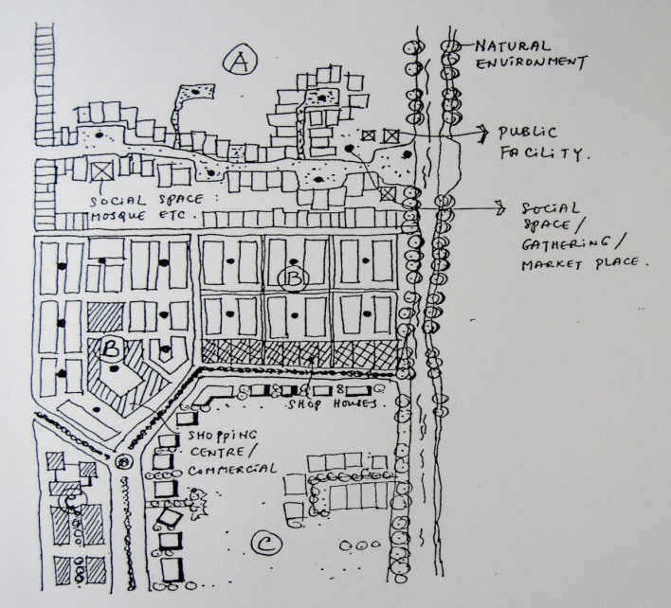
Figure 1. Schematic representation of the three neighborhood settings.
Sources: modification drawing from Rapoport (1997)

Some urban areas in Jakarta are as follows:
A. Urban “Kampung” / Low income settlement
B. Medium and high income residential area / Real-estate and high rise
apartment + Shopping area
C. Center of the City

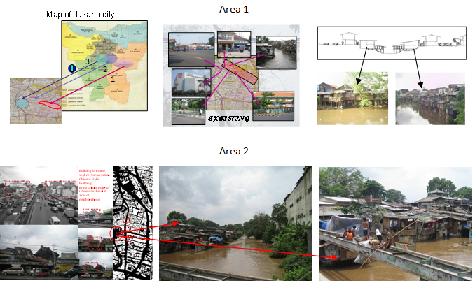
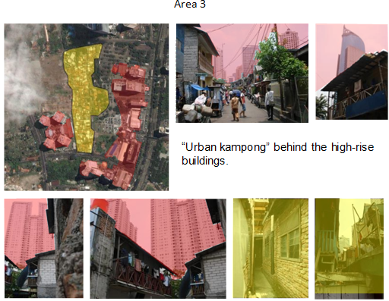
Figure 2. Urban Kampung zone in some area of Jakarta.
Picture taken by Sutrisno and google map

The development of cities with high rise buildings mixed with the conditions of displaced villages or the loss of local geniuses has created the interest of handling the urbanization problems, physically, socially, culturally and economically integrated in a more creative way. The approach to social sustainability is needed in dealing with more comprehensive problems. Colantio and Dixon (2011) explained the importance of developing and regenerating cities in solving city problems. The policy launched was to develop cities on the basis of the needs of their communities to achieve social sustainability which could bring well-being to their communities. This is also in line with Nan's (2013) thinking which explains that the achievement of the prosperity of the city is based on the needs and problems that exist in the community of that city.
The following Figure 3 is the implementation of indicators of success in achieving social sustainability, proposed by Colantio and Dixon (2011).

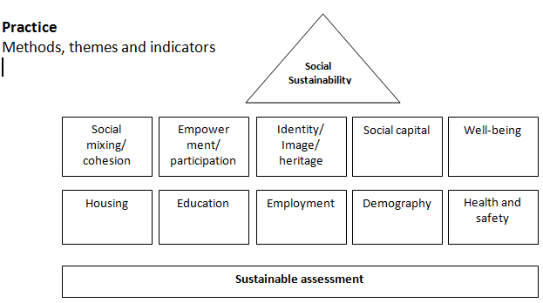
Figure 3. The Social sustainability assessment frame work.
Source: Colantio (2011,p.216), see also Colantio and Dixon (2009)

Existing and Implemented Policies
In facing the problems and challenges of urbanization, various policies have been implemented by developing and developed countries in overcoming the problems of the city. According to Colantonio and Dixon (2011, p. 218), in reviewing the developments in the 1990s-2000s, research and policies developed specifically in Europe are more focused on social capital promotion, participation and empowerment. Whereas starting in the 2000s, research in the field of well-being (personal, social, and economic well-being) and quality of life have been implemented to create city live ability (Gehl, 2010, Setha, 2017).
The policy has become the theme of development in both research and practice. The development of the policy made is based on the development in overcoming problems that exist in a particular era. For example, the development of social sustainability policy in the 1940s-2000s (traditional) was on the theme / field of fulfillment of basic needs (including housing and environmental education, education and skills, employment, equity, human rights and gender issues, poverty and social justice). In 2000s were more developed to create sustainable places that can improve the well-being of the community, such as: themes of demographic change development, social mixing and cohesion, identity, sense of place and culture, health and safety, social capital, well-being and quality of life (Colantio and Dixon, 2011).
Some of the themes developed into policy issues and success indicators of social sustainability are as follows:
Table 1. Theme of development as outlined in policy.
Sources: Colantio and Dixon (2011, P.270)
Themes | Key policy issues
Health, happiness and well-being | Supporting healthy living, such as: healthy internal and external microclimate, access to health facilities, to leisure routes and recreation spaces etc.
 | Creating opportunities for community, such as: Creating sociable space networks,public realm vibrancy and intensity, "third" places and city's living rooms, communal & non-consumptive spaces etc.
 | Changing lives and realising potential, such as: focus on five key "well-being" themes (aspirations, environmental quality, access to employment, housing standards, and public services).
Regeneration | Location and Connectivity
 | Contextual analysis
 | Engagement process
 | Neighbourhoods and liveability
 | Community and Stewardship
 | Economic diversity and independence
Environmental sustainability | Energy systems
 | Car Dependency, such as: low carbon transport strategy, living and flexible working patterns, etc.
 | Waste minimization
 | Food supply
 | Construction proccess/materials
 | Water cycle (management of water resources)
Urban design (Personal, Social, Economic and Material well-being) | Permeability street network
 | Public realm and enclosure of space
 | Density and mix of uses
 | Quality, diversity and distinctiveness
 | Bioversity by Design

In the case of Indonesia, many development policies have been launched during the last five decades, especially in the scope of policy and implementation to improve infrastructure, settlements and housing, and the development of public spaces. Some developments in the housing providing were the construction of flats that accommodate urban communities whose live improperly on the banks of rivers, or less habitable housing (Srinaga, 2014 & Srinaga, Martin and Hidayat, 2015).

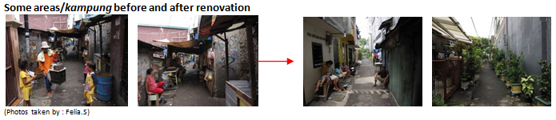
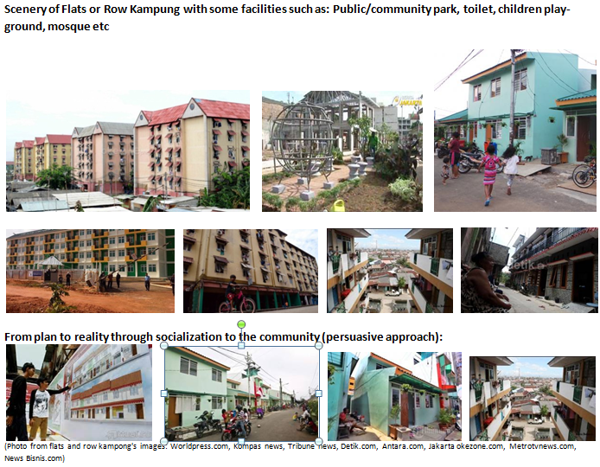Figure 4. Flats Kampung and Row Houses or Row Kampung in Jakarta
The implementation of the existing policies has produced good results. However, the micro problems in individuals, communities, lifestyle characteristics of Jakarta community and migrants, need more appropriate strategy in dealing with social, cultural and economic problems. The people are already accustomed to work in and around the house. The activities in the micro space of city need to be handled in three focuses of development, namely:

- Activities and culture (culture heritage) which is a legacy that lives continuously, such as areas / communities with selling / market activities and traditional public spaces, such as roads, parks and fields.
- The development of popular public spaces, with large-scale economies such as malls that remain in a city.
- The development of alternative public spaces, such as maintaining local traditions that characterize a city in Indonesia, including Jakarta as a metropolitan city.

Strategic Planning Solution and Development
The needs and geographical location / urban settlements in Jakarta require handling transitional space such as the improvement of urban public space (Srinaga, 2012). The use of city public space in Jakarta, needs to create alternative public spaces such as culinary areas, special trade areas that are closely intertwined with other urban public spaces, provided with adequate pedestrian and city transportation.
Designed activities need to be adapted to the needs of the community and becomes the mirror of the community. Several strategies which can be performed to solve the problems of city spaces in Jakarta and its surrounding areas are as follows (Paul, 1993, Srinaga, 2013):

Problems/themes | Strategies/suggestion
Access and Permeability | Raising permeability by creating access and close relation / interaction with the surrounding environment
Socio-cultural | Creating joint activities and public spaces /inter-spaces  Providing joint activities like joint sports activities, traditional and modern food , etc
History | Returning collective memory, in the forms of food and beverages, goods selling, etc
Time and activity | Creating activities with longer operational time, in line with Jakarta ‘s community lifestyle which often gather outside their houses after dinner time
"Design" | Combining new design without leaving its local genius
Type and Form | Utilizing existing typology in the old areas and making public spaces adapted to the character and lifestyle of its community
Experiencing | Old locations need some repairs, new ones need additional activities
Representative meaning | Be renovated and socialized with the support of the government and community.
Dialogue and interaction | Need attempts to create various joint activities in public spaces

Whereas to address the needs of residential areas which can be joined with business place, the development of live-work housing needs to be developed. Some types of live-work are as follows (Dolan, 2012):
- Home Occupation
- Work/live
- Live/work: Live-with, live-near, live-nearby
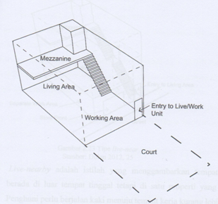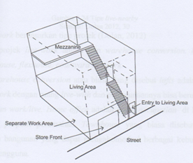
Type Live-with sources: Dolan (2012,22) Type Live-near, sources: Dolan (2012,25)
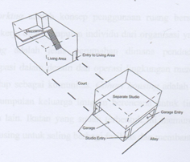 Type live-nearby, sources: Dolan (2012,30)
Figure 5. Type of Live/work housing, Dolan (2012)

Some macro and micro strategies need to be developed jointly in overcoming urban problems especially due to the high level of urbanization. Macro strategy in the form of infrastructure improvement and development and improvement of economy and social sustainability, as well as micro development in the form of the creation of urban public spaces (Donovan, 2018 & Srinaga, 2012). They can improve well-being and settlement arrangements that provide freedom of work by maintaining characterized local genius. However, they must be accompanied by strict government policy. The macro policies need to be developed include: even distribution of urban development in accordance with special characteristics of local community, improvement of identified special facilities and policies with regard to the development of physical, economic and social needs (Nan, 2013). Whereas the micro policy needs to focus on handling the social-cultural sustainability by increasing the empowerment of local communities.

Conclusion
In conclusion, there are at least important strategies to note:
- Well controlled urbanization to bring benefits to urban development, especially for its economic development. However, the socio-cultural and psychological problems that characterize life of migrants need special attention, as well as for urban governance (e.g. integrated working and housing area, open public space).
- Show a structural transition from a country which was initially dominated by the agricultural economy and rural areas, to an urban economy driven by manufacturing and service sectors, so that the residential areas have to be accommodated in accordance with their life style in achieving well-being.
- Improve the quality of human resources by providing skilled workers to prepare city community to be able to play an active role to enter the labour market in urban growth and ultimately can reduce poverty in urban areas.
- Create competition and economic growth in an area. In spite of negative impressions and problems, urbanization can be regarded as an advantage for socio culture. It could make significant contributions to urban societies and environment.
- Put forward the policies and strategic planning in the physical and economic fields in order to achieve well-being and to improve quality of life.

References
Colantio, A and Dixon, T 2011, Urban Regeneration & Social Sustainability: Best Practice from European Cities, John Wiley & Sons Ltd, United Kingdom.
Dolan, T 2012, Live-work Planning and Design: Zero-commute housing, United Stated of America.
Donovan, J 2018 Designing the Compassionate City: Creating Places Where People Thrive. Routledge, London.
Gehl, J 2010, Cities for People, Island Press, Washington D.C., USA.
Lennard, S 2012 Healthy Communities through True Urbanism, The 49th International Making Cities Livable Conference, Portland, OR, USA.
Nan, E 2013, Good Urbanism: Six Stepes to Creating Prosperous Places, Island Press, Washington D.C., USA.
Paul, C 1993, Applications of Environment-Behavior Research: Case Study and Analysis, Cambrigde University Press, Cambridge.
Rapoport, A 1977, Human Aspects of Urban Form: Towards a Man- Environment Approach to Urban Form and Design, Pergamon Press Ltd., Headington Hill Hall, Oxford.
Setha, L 2017, Spatializing Culture: The Ethnography of Space and Place, Routledge, London.
Srinaga, F 2006, The Relationship between Valence and Individual’s Attitude toward Urban Public Space: A Study of place attachment to Provide well-being, Dissertation, University of Indonesia, Indonesia.
Srinaga, F 2012, Building Social Engagement through Creating Place's Vitality, the 49th International Making Cities Livable Conference, Portland, OR, USA.
Srinaga, F 2013, Reshaping The Role Of The Square In Fostering Inclusive Social Interaction, the 50th International Making Cities Livable Conference, Portland, OR, USA.
Srinaga, F 2014, Creating Neighborhood Health: Integrating Play Street, Singing Home Zone and Dancing Square, the 51th International Making Cities Livable Conferences, Portland, USA.
Srinaga, F, Katoppo, M & Hidayat, J 2016, Community Participation to Combat Poverty and are for Their Common Homes (case Study: Kampong Mauk, Tangerang, Indonesia), the 53th International Making Cities Livable Conference, Rome, Italy.
UN-Habitat (undated) Sustainable Development Goals. UN Habitat. Accessed April 2019, https://unhabitat.org/un-habitat-for-the-sustainable-development-goals/and https://unhabitat.org/sdg-11-executive-summary/UN-Habitat (2013).
World Health Organization 2007, Global Age-Friendly Cities: A Guide, WHO.
World Health Organization 2016, Urban Green Spaces and Health, Copenhagen: WHO Regional Office for Europe.

